**5643 final project**



**SMART MOUSE TRAP**

**By**

**Fevzi Ozaydin, Violet Mwaffo**

**PhD. Candidates**

**Department of Mechanical & Aerospace Engineering**

December 2012

# Abstract

In this project, we build a “smart mouse trap” where a mouse will be caught and kept alive so that it wouldn’t decompose and become a breeding ground for maggots in case of people forget to check or while they are away from their house. This way, they will only know when a mouse was caught and deal with it as soon as possible.

The trap is built using a simple project enclosure. There is an opening cut into one end where the mouse enters the trap to get the cheese. The cheese is placed on the far end of the box so that the mouse must completely enter the enclosure to get it. About 2/3 of the way to the opposite end of the enclosure we place an IR emitter and an IR detector.

When the mouse crosses between them to get the cheese, he breaks the beam. This causes a servo to swing a trap-door over the hole trapping the mouse. An alarm beep sounds to alert us that we have caught a mouse. And a LED switch from green to red. We also use a LCD display to show “Awaiting Mouse” sign initially and as soon as the mouse is caught it will change to “Mouse Caught”.

Contents

Abstract 2

Introduction 4

Materials and methods 5

Sensor and materials 5

Cost of material 9

Circuitry 0

PBASIC program 1

Conclusion 4

Instructions 5

References 5

# Introduction

Many families who live in rural New Jersey have mouse problems. Normally people would stick a piece of cheese in a snap-trap and call it good. Everyone has mixed results. Either the mouse would take the cheese and not set the trap off, or they would get nailed and make a mess out of the area where the trap was set. Worse yet if people didn't remember to check the trap, the first indication they get is the smell. Being busy with their daily routines most of the time people place the trap in the food cabinets and they forget to check it for days until the house was swarmed by flies and the cabinet has full of maggots crawling around the food cans and on the remnants of the mouse.

A smart mouse trap despite its cost is the ideal solution to trap a mouse alive and therefore avoid all the inconvenience from putrefaction. Advocate for animal protection might also find this house appliance ideal to catch an animal without killing it.

The device relies on the infrared light detection which is invisible to animal. Emitters coupled to a receiver are placed at opposite end of the cage. A beam of light goes straight from one end to another of the cage. The circuit is controlled by a Parallax Basic Stamp kit processor which checks at any time the presence of the light beam. In case the beam come to be interrupted, the microprocessor send a command to the servo to close the gate and the gate remain closed even if the light beam is detected again. This insures the mouse does not get out of the cage. Once the gate has been closed, only a human can press a button to open the gate again. At that time the trap is ready to operate again.

The document is organized in four sections plus the introduction. In the second section, we present the materials and the methods used to design and build the smart mouse trap. The third chapter presents the circuitry, the links between the components and PBasic code to control the whole system. In the last section, we conclude.

# Materials and Methods

## *Sensors and Actuators*

One sensor is implemented in this device. The Parallax’s infrared sensor is used in this device. A transmitter or source converts an electrical signal to an optical signal. This signal is emitted at an amplitude of 40-kHz in order to avoid any interference with all natural IR source. A receiver or detector converts optical power into electrical current by detecting the photon flux-incident on the detector surface. It contains the necessary IR detector, amplifier, filter, demodulator, and output stages required to convert a 40-kHz IR signal into 5-volt logic levels.

|  |  |
| --- | --- |
| IR LED, Stanoff, and Shield Assembly | IR Receiver |

**Figure 1: Infrared Sensor, emitter and Receiver**

|  |  |
| --- | --- |
|  |  |

**Figure 2: Functional Mechanism of the Infrared Sensor**

A servo motor is used as an actuator in the system. Servo motors are DC motors with feedback position control. This actuator has a torque value of 3.4 kg·cm, which is sufficient to open and closed the gate. The servo motor is interfaced with the BS2 via a 3-pin connection.

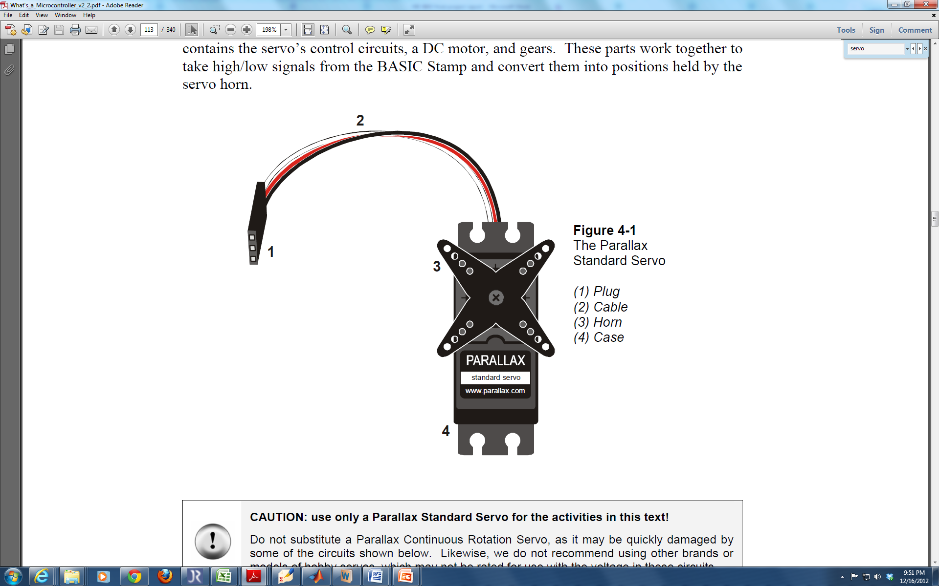

**Figure 3: Parallax standard servomotor**

A liquid crystal display (LCD) component is used as a user interface to display the welcome message, a message of “Awaiting Mouse” and a message of “Mouse Trapped” in **Error! Reference source not found.**. The LCD is a Parallax 2x16 serial LCD, and is interfaced with the BS2 via a 3-pin connection.

|  |  |
| --- | --- |
|  | http://cdn.tristro.com/eimage/search/parallax-350-00006-M.jpg?v=113 |

**Figure 4: Parallax LCD display and LED**

The LED remains light up after the door has been closed and even in case the signal is reestablish. This is to let people know a mouse is still inside. The LED is turn off once the button is pressed and the mouse release.

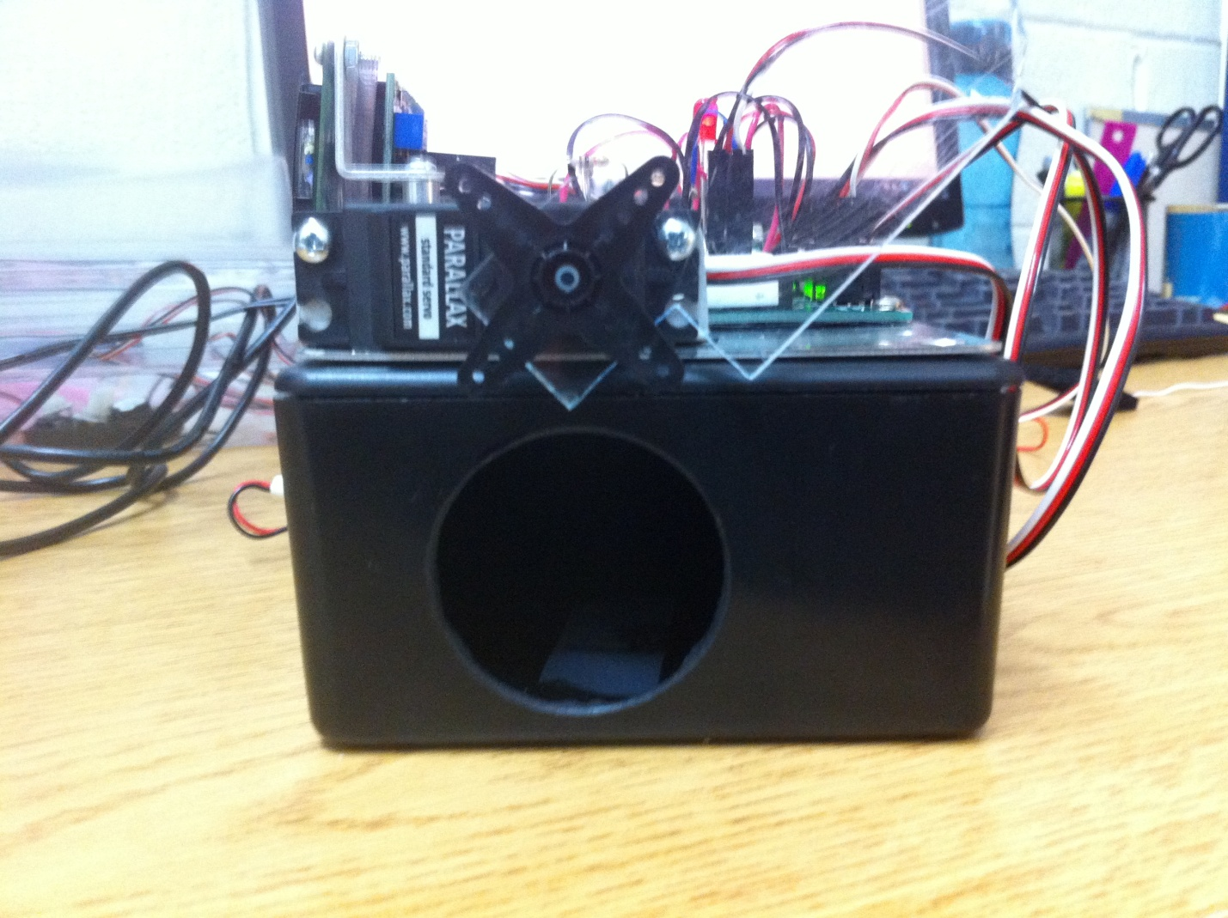

**Figure 5: Mouse Trap Structure, A circular hole a made into a Radio Shack project enclosure that serves as the trap. A Plexiglas gate is attached to a servo and maintains the enclosure open if there is no mouse inside and closed whenever a mouse is detected inside.**

The structure which houses the mouse trap is composed of Plastic for the enclosure and Plexiglas for the gate. Holes were drilled in several locations in order to allow for appropriate wiring between sensors and the BS2, which is housed at the top compartment of the structure.

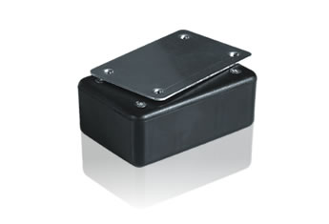

**Figure 6: Project enclosure Radio Shack**

The piezo speaker emits an alarm sound when the mouse is caught to prevent the house occupant of the presence of mouse inside the enclosure.

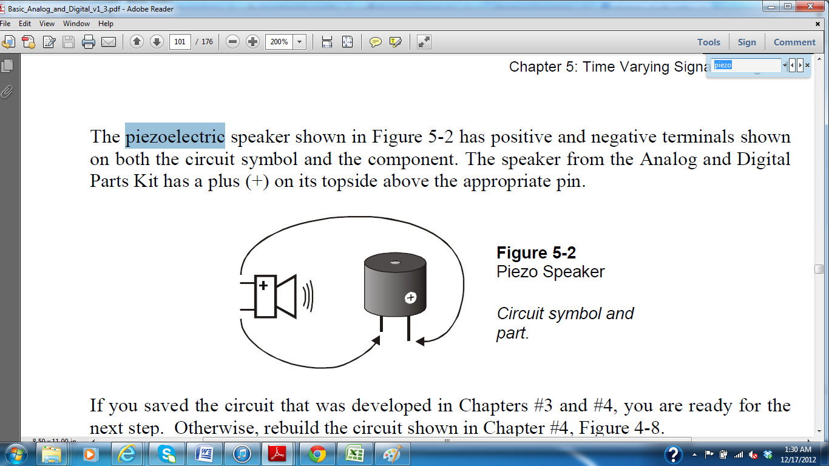

**Figure 7: Piezo Speaker**

The push button play an important role one the mouse is trapped. In fact the door remains closed when the infrared signal is interrupted and remain closed till the button is pressed an enable the door to open again and to exit the mouse from the trap.

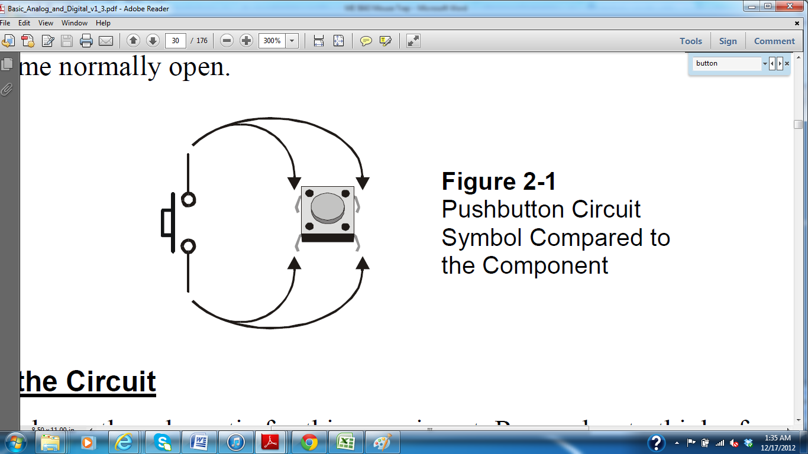

**Figure 8: Push Button**

### Cost of material

### Table 1: Bill of material for prototype construction, including the estimated cost per unit and the total cost for each material. The overall prototype cost is estimated to be $238.82.

|  |  |  |  |  |
| --- | --- | --- | --- | --- |
|  | Material | Cost per unit ($) | Quantity | Total cost ($) |
| 1 | IR sensors Emitter and Receiver | $20.00 | 1 | $20.00 |
| 2 | 2 mm thick Plexiglas | $105.00/m2 | 0.016 m2 | $15 |
| 3 | LCD display | $25.00 | 1 | $25.00 |
| 4 | Servo motor | $13.00 | 1 | $13.00 |
| 5 | BS2 microcontroller | $100.00 | 1 | $100.00 |
| 6 | Button | $3.19 | 1 | $3.19 |
| 7 | AA battery | $1.00 | 1 | $2.00 |
| 8 | Project Enclosure (5x2.5x2") | $5.49 | 1 | $5.49 |
| TOTAL PROTOTYPE COST = | | | | $183.68 |

### Table1. presents a complete bill of materials and components used in the construction of the mouse trap. The estimated sum of these materials is approximately $183.68 per unit. It is expected that this per unit cost would decrease significantly if this device were to be produced at a large scale. The reduction is estimated to be approximately 75 %, making the mass production cost per unit around $45.

## 

## Circuitry

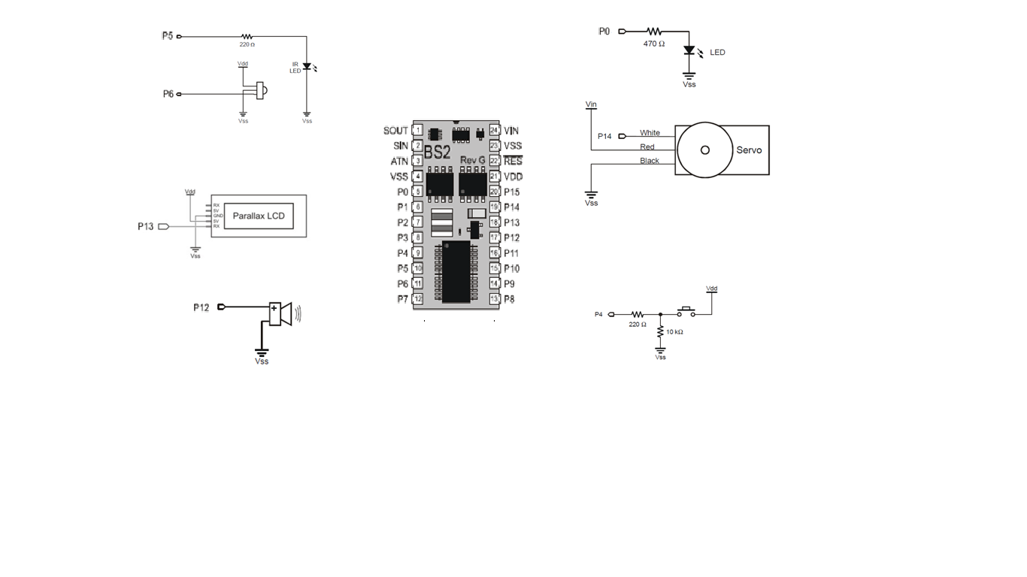

**Figure 9: Complete circuitry for the mouse trap**

## 

## PBASIC program

' {$STAMP BS2}

' {$PBASIC 2.5}

‘Declare variables

'LCD enable PIN 14 (1 = enabled)

WLED CON 13 ' Warning LED Output

ALM CON 12 ' Alarm Output Pin

Srvo CON 15 ' Servo Control Pin

IFR CON 8 'infrared pin

Pos VAR Word 'control the servo position

Cnt VAR Byte

Counter VAR Byte

IR_detect VAR Bit

btnWrk VAR Word

'DIRS = %1111111101000000 ' Set Outputs

' -----[ Program Code ]----------------------------------------------------

main:

GOSUB IniMess

PAUSE 5000

Pos = 1250 'open the gate

Cnt=1

GOSUB PanServo

LOW 7

here:

PAUSE 50

FREQOUT 5, 1, 38500

IR_detect = IN6

IF IR_detect = 0 THEN unbroken

GOSUB Alarm

GOSUB WRLCD

GOTO here

unbroken:

GOSUB LCDcmd

GOSUB press

GOTO here

RETURN

' -----[ Subroutines ]-----------------------------------------------------

IniMess: ' Initialize the LCD

SEROUT 14, 84, [22, 12] ' Initialize LCD

PAUSE 5

SEROUT 14, 84, ["Mouse Trap", 13, ' Text message, carriage return

"Team 8 2012!"] ' more text on line 2. ' LCD to character mode

RETURN

Alarm:

Pos = 500

HIGH WLED

cnt=1

GOSUB PanServo

FOR counter=1 TO 3

FREQOUT ALM, 500, 5000

NEXT

RETURN

LCDcmd:

SEROUT 14, 84, [22, 12] ' Initialize LCD

PAUSE 5

SEROUT 14, 84, ["Awaiting Mouse", 13, ' Text message, carriage return

"Team 8 2012!"] ' more text on line 2. ' LCD to character mode

RETURN

WrLCD: 'OUTC = char >> 4 ' output high nibble

SEROUT 14, 84, [22, 12] ' Initialize LCD

PAUSE 5

SEROUT 14, 84, ["Mouse Trapped!", 13,' Text message, carriage return

"Bingo"] ' more text on line 2.

PAUSE 5000

RETURN

PanServo: 'subroutine to control the servo

PULSOUT Srvo , Pos

PAUSE 10

Cnt = Cnt + 1

IF Cnt <> 40 THEN PanServo

RETURN

opengate:

Pos = 1250

Cnt=1

GOSUB panservo

LOW WLED

RETURN

press:

DIR0=0

LOW 0

BUTTON 0, 1, 255, 250,btnWrk,1,opengate 'The button is at pin 0

'PULSOUT 14, 1050

PAUSE 20

RETURN

# Conclusion

The mouse trap is a tremendous home device that enables to catch mice alive. It work well while activated and in our tests no particular issue has been notice. It is use less energy while awaiting the mouse. In fact only the IR Emitter and receiver are activated at this point and the LCD also displays a message but the backlight is turn off. When a mouse is detected the LED remain lit after the door closed, until it is reopen again. So power consumption increase a little bit more after the mouse has been captured. This is the cost to pay in order to prevent the house occupant that the mouse is present inside the trap.

The device is made of electronic components and must be protected from humidity. There is no particular safety issue since the device uses a 9V battery to operate. The device as it is conceive can also be used to capture other animal alive. This particularity might be very useful for animal protection.

# Operating Instructions

1. Verify the battery or the power supply of the device.
2. Turn the switch of the BS2 in mode 2
3. A message is displayed on the screen and after 5 seconds, the gate opens and the trap is ready to operate
4. A message displays “Awaiting mouse”
5. When a mouse interrupts the IR light beam, the door closed, the LED lit and the buzzer sounds.
6. The door remain closed even if the IR beam is reestablished
7. To remove the mouse, press the button and the gate open
8. The device is ready to operate again.
9. No calibration is required to operate.
10. Avoid putting the device in a wet area

# References

1. Vikram kapila, Mechatronics Notes, Polytechnic Institute of NYU, 2012
2. Parallax Inc, Smart Sensors and Applications, Student Guide version 1.1, 2006
3. Parallax Inc, Robotics with the Boe-Bot Student Guide version 2.2, 2003-3004
4. Parallax Inc, BASIC Stamp Syntax and Reference Manual version 2.2, 1994-2005
5. Parallax Inc, What’s a Microcontroller? Student Guide version 2.2, 2003-3004
6. Parallax Inc, Stamp Work, Experiments and Basic Stamp source code, 1994-2005