Damped Vibrations

Introduction
A vibrating body is one which oscillates periodically about an equilibrium position. If the vibration is damped, the amplitude of the vibration will approach zero as time progresses. For example, a child swinging on a playground swing will eventually return to her original rest position if no one pushes her. The damping effect here is due to the friction between the chains of the swing and the bar holding it up. The friction generates heat and thus removes energy from the system. Note friction is not synonymous to damping, rather friction is a type of damping.
The position, velocity, and acceleration of a body undergoing damped can be described by the relationships
(1) 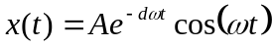
(2) 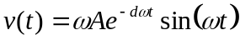
(3) 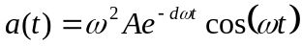
respectively, where A is the initial displacement, ω is the angular frequency, and d is the damping coefficient. These equations are approximations and hold only if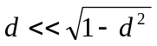, which is usually the case. A plot of acceleration is shown in Figure 1.
For periodic vibrations ω is determined by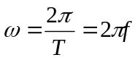where T is the period and 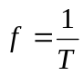 is the frequency of oscillation. For this particular experiment (Figure 2), ω is also known as the natural frequency and can also be determined from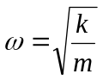where k is the spring constant and m is the mass of the body.
From inspection of Figure 1, the acceleration at t = t₁ is
(4) 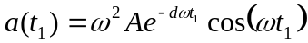
and the acceleration at t= t₂ is
(5) .
If the ratio of (4) and (5) is taken, we get
(6) 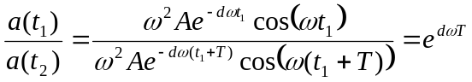
By taking the natural logarithm of both sides of (6), we can find the damping coefficient d.
(7) 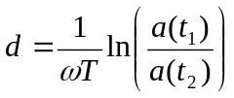
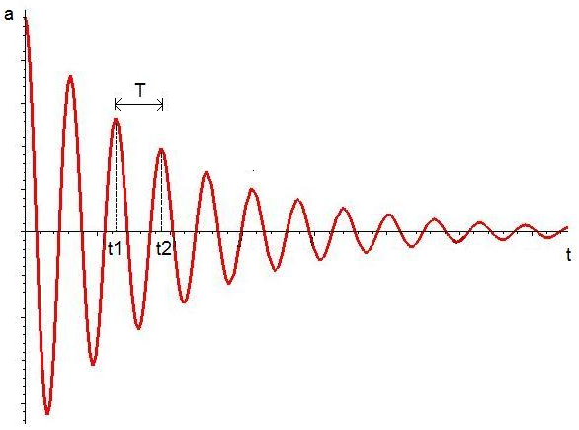
Figure 1 An a-t curve for a body undergoing damped vibration.
In this experiment, an accelerometer will be utilized to verify various results of a mass-spring system undergoing damped vibration.
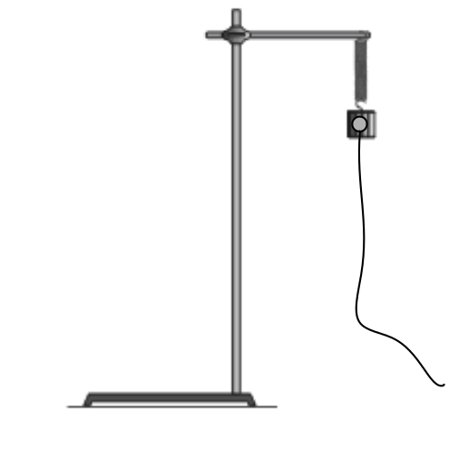
Figure 2 Vibrating mass-spring system

Objective
- Determine the damping coefficient of the mass spring system.
- Determine the period, frequency, and natural frequency.
- Determine whether natural frequency is dependent on mass or initial displacement.

Equipment List
Windows PC | ring stand, rod, and clamp
LabPro or Universal Lab Interface  Logger Pro  Vernier Accelerometer | spring or rubber band  tape  twist ties
200g and 300g masses

Preliminary Questions
1. Attach the 200g mass to the spring (see Procedure Step 1). Pull the mass down 2-3cm and release. Observe the motion. Sketch a graph of position vs. time for the mass. On the same set of axis, sketch the graphs of velocity vs. time and acceleration vs. time.

Procedure
1. Attach the spring to a horizontal rod connected to the ring stand and hang the mass from the spring as shown in Fig 2. Securely fasten the 200g mass to the spring and the spring to the rod using tape so the mass cannot fall.
2. Connect the Accelerometer to Channel 1 the LabPro Interface. Open the LoggerPro software. The appropriate graph should appear. Attach the Accelerometer to the mass with a piece of tape. Make sure the arrow on the accelerometer points down. With the mass stationary, click the ZERO button.
3. Pull the mass down a 2-3cm (A) and release. The mass should oscillate along a vertical line only. Click  to begin data collection.
4. After 3s, data collection will stop. The acceleration graph should show a curve similar to Figure 1.
5. Compare the acceleration graph to your sketched prediction in the Preliminary Questions. How are the graphs similar? How are they different?
6. Click on the Examine button, . The Examine button allows you to trace the graph. Find the period of oscillation (T). This can be achieved measuring the time interval between adjacent peak accelerations. Determine the frequency (f) and natural frequency (ω). Using ω, determine the spring constant (k). Find the damping coefficient (d). Record all measurements in the data table.
7. Repeat Steps 3 and 6 with an initial displacement of 5-6cm (A) with the same 200g mass. Does the period (T), frequency (f), or natural frequency (ω) change with larger amplitude?
8. Change the mass to 300g and repeat Steps 3 and 6. Does the period (T), frequency (f), or natural frequency (ω) change with increasing mass?

Data Table
Trial | Mass  (Kg) | 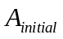  (m) | T  (s) | f  (Hz) | ω  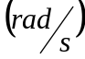 | k  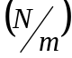 | d
1
2
3

Analysis
1. Does the frequency, f, appear to depend on the amplitude of the motion? Do you have enough data to draw a firm conclusion?

2. Does the frequency, f, appear to depend on the mass used? Did it change much in your tests?

3. How does the mass of the accelerometer affect the natural frequency? Does it increase?
Does it decrease?

