NAME: _______________________

Diffusion through a Membrane

By Meetu Walia

1. Pre Lab Questions:

1. Define the following terms in the space provided:

- Diffusion

- Concentration Gradient

- Osmosis

- Passive Transport

It is through diffusion that cells are able to obtain food and get rid of their waste products. For example, metabolic processes in animals and plants usually require oxygen, which is in greater concentration outside the cell, thus the net flow of oxygen is into the cell.

2. Background Information:

Equilibrium is a key concept in understanding diffusion. Equilibrium occurs when the concentration of a substance is equal throughout the medium. If diffusion occurs when there is a concentration gradient, equilibrium will eventually occur.
2.1 Factors Affecting the Rate of Diffusion:
There are many things that affect the rate of diffusion, especially diffusion across a cell membrane.
- The steepness of the concentration gradient
- The membrane that the molecules have to diffuse across. For example, if a cell membrane is hydrophobic (water-hating), the water molecules will not pass through the membrane. In affect, the water molecule will collide with other molecules and change the rate of diffusion
- Neighboring molecules affect the rate of diffusion. For example if a particle that is able to diffuse across a certain membrane is surrounded by some neighboring molecules, the rate of diffusion can either be inhibited or enhanced.
- Temperature
- The size of the molecules

2.2 Measuring the Rate of Diffusion:
The rate of diffusion can be measured by observing the change in concentration of the ions over a period of time. Since the ions are electrically charged and able to conduct, a conductivity probe can be used to monitor the change in conductivity of the ions in a solution over a period of time.

3. Objective:
The purpose of this experiment:
- Use the conductivity probe to measure the change in ionic concentrations in a solution over a period of time
- Study how different factors affect the rate of diffusion

4. Equipment list:
- Computer 10- 1% and 10% salt solution
- Vernier computer interface 11- 5% starch solution
- logger pro 12- Stir Hot plate
- Vernier conductivity probe 13- Iodine
- dialysis tubing (pre-soaked in water) 14- Funnel
- beaker 15- Stirring rod
- scissors 16- Graduated cylinder
- distilled water 17- Ring stand
- dental floss

5. Experimental Procedure:
- Connect the conductivity probe to the computer interface.
- Prepare the computer for data collection

5 A- Concentration Gradient:
- Measure 300ml of distilled water and place it in the 400ml beaker
- Obtain a dialysis tube which contains 1% salt solution and submerge it into the beaker
- Position the conductivity probe into the water as shown below in Figure 1.
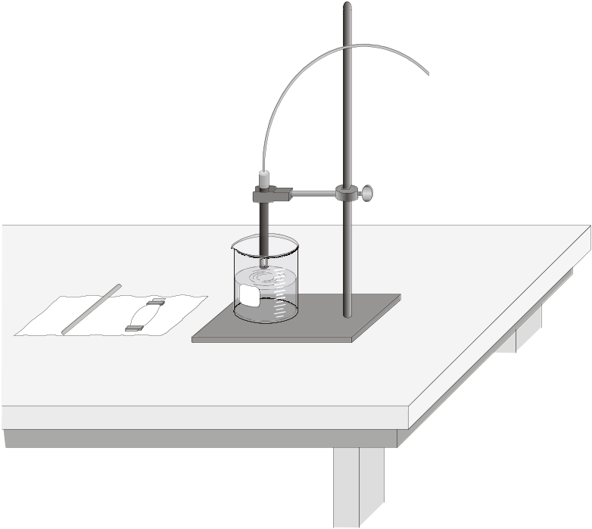
Figure 1
- Using a stirring rod, stir the solution for about 30 seconds and start collecting the data by clicking 
- Collect the data for two minutes and continuously stir the solution. After two minutes, the data collection will stop automatically.
- To determine the rate of diffusion, highlight the section of the data from where the values start to increase.
- Click the Linear Fit button to perform a linear regression and a box will appear with the equation of the best fit line.
- The slope of the line (m) is the rate of diffusion and record that value in Table 1 in the Analysis section.
- Remove the dialysis tube and repeat the same steps using 10% salt solution. Make sure you change the distilled water in the 400ml beaker.
- Save the data as concentration.cmbl

5B- Effect of other molecules:
In this part of the experiment we will be testing the rate of diffusion with the presence of another molecule
- Obtain a dialysis tube that contains 10% salt solution and 10% starch solution from your instructor
- Submerge the dialysis tube into a beaker filled with 300ml of distilled water.
- Repeat steps 3-10 from Part 5a.
- Save the data as Othermolecule.cmbl

6. Analysis/Assignment:

Table 1
Salt concentration (%) | Rate of diffusion (mg/L/s)
1%

10%

Table 2
Dialysis tube concentrations | Rate of diffusion (mg/L/s)
10 % salt/10%sugar

Questions:

- How would one be able to figure out the concentration of the toxic chemical that has been diffused across the membrane with knowing the rate of diffusion and the time that has passed? (Hint: look at the units)

- Which molecules diffused through the membrane and which didn’t diffuse in Part B of the experiment and why?

- Compare the rate of diffusion for the 10% salt solution with the rate of diffusion for the 10%salt/10%sugar solution. Give a valid explanation for this occurrence.

- What are some sources of error in this experiment?

- Design an experiment that would show how temperature affects the rate of diffusion. Predict your results and give an explanation (attach an extra sheet if you need more space).

- Challenge: Predict what would happen to the rate of diffusion if the water in the beaker in which the dialysis tube is submerged is not replaced for each trial. Why?

- Challenge: Based on the data and your observations, how can we inhibit the rate of diffusion so more of the toxic chemical can be disposed of?

Pre-lab Preparations:
  - For the starch solution, add 5g of starch to 100ml of water and heat the solution slowly until the starch dissolves. The solution will appear to be slightly cloudy. After the solution has been slightly cooled off, add 5-6 drops of iodine-potassium iodide solution
  - Soak the dialysis tubing in distilled water for at least 3-4 hours before use.

